**Reading 1**

Two-player competitive game- understood (by searching online) the terminologies like a game tree, utility, the root node, terminals (leaf nodes), minimax and maximin, depth, and branching factor.

Two-player zero-sum games- the other player’s loss exactly balances one player’s gain. The total utility available in the game is constant; hence, the sum of the gains and losses of all players is zero. Eg. Chess.

Two-player constant sum game- the total payoff for all the players remains the same irrespective of the outcome.

Strategy-

1. Deterministic: a player's action at a specific state is fixed and predetermined.
2. Randomized: probability is incorporated into the decision-making.

Games with partial information- utility changes according to the probability distribution of choosing the next set of moves.

Subgame and Subgame perfection – Subgame represents a subtree rooted at a node, which is not a terminal. It can independently be treated as a game for better analysis.

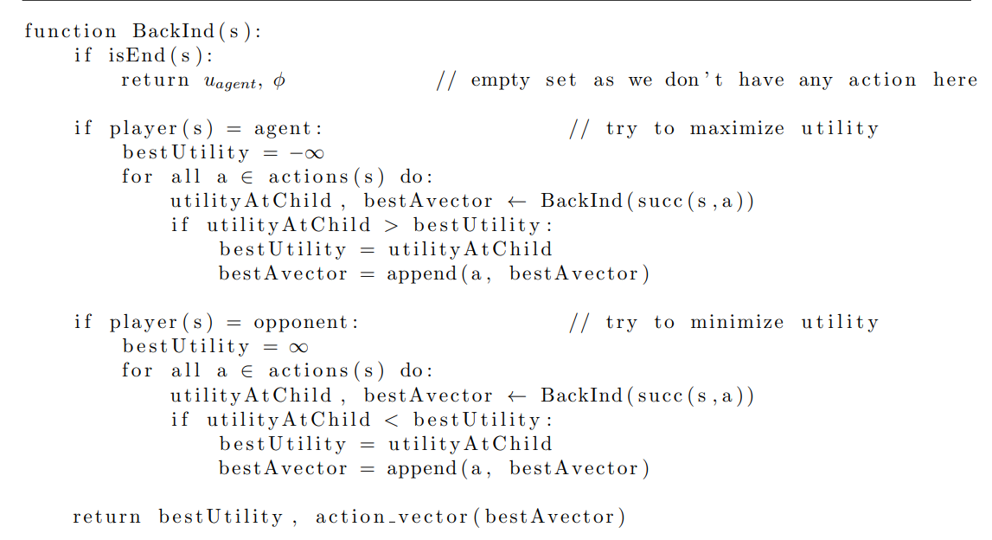

This is the backward induction algorithm. The player (agent) wants to maximize the utility, while the opponent wants to minimize the utility for the agent.

**Reading 2**

Computation of utility by checking each node can be very time-consuming, with games like chess requiring about 10170 computations, hence there is an acute need to deploy algorithms that do not require to search every path for finding the optimal one.

Depth-limited search algorithm: A variation of a Depth-first search algorithm where the computation stops after a prescribed depth. This prevents the computation from getting stuck in loops and saves time.

Alpha-beta pruning is an excellent alternative to the Minimax algorithm. It prunes the branches so they do not affect the final decision. ‘a’ is initialized to -inf, and ‘b’ is initialized to +inf. ‘a’ is computed by max (a node_val), and ‘b’ is computed by min (’b,’ node_val). If ‘a’ > ‘b,’ then the branch is pruned. The time complexity is (bd/2), against (bd) with the Minimax algorithm, where b is the number of children, and d is the depth.

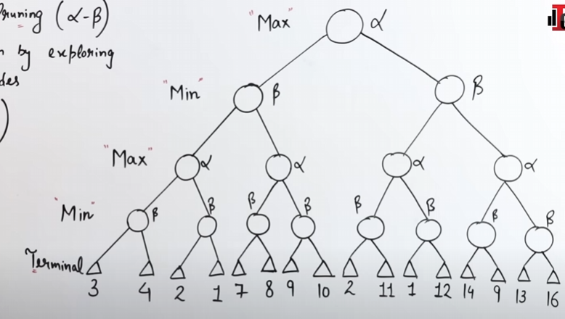

*Snapshot from a video explaining alpha-beta pruning*

Simultaneous move games: unlike chess, where the players move sequentially, some games require the players to play simultaneously. E.g., football. Here, a matrix can be prepared to deal with a situation in the game.

Equilibrium: no player gains by unilateral deviation from their strategies.

max min u (s1,s2) < = min max u (s1,s2)

If these are equal, then equilibrium exists. The equilibrium point is known as the saddle point.

**Reading 3**

Not all games have total utility as zero, so a win for one is not necessarily a loss for the other.

Strategy:

1. Strictly dominated: for all possible combinations, the utility of P1 remains greater than P2.
2. Weakly dominated: for all possible combinations, the utility of P2 remains lesser than or equal to that of P1.

The same goes for strictly and weakly dominating strategies.

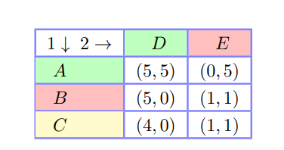

In the above figure, we can determine a strategy to be dominant or dominated w.r.t other strategy by fixing the strategy for other player and comparing the utilities in all possible situations.

E.g. For P1: u (B, D) and u (B, E) are respectively >= u (A, D) and u (A, E), thus B weakly dominates A for Player 1.

**SDSE (Strong Dominant Strategy Equilibrium)**: In game theory, SDSE refers to a situation where a player's strategy is dominant, meaning that it is the best choice regardless of what other players do.

A WDSE is a situation where each player's strategy is such that they cannot profitably deviate from it, even if they know what the other players will do.

**Nash Equilibrium**

A Nash equilibrium is a set of strategies for all players in a game such that no player can unilaterally deviate and improve their payoff. In other words, at a Nash equilibrium, each player's strategy is the best response to the other players' strategies.